Send Master Integration Documentation

This document compiles all findings from the decompiled source code of Send Master (client Blazor Server project and common library) to understand how the integration works, its components, database schemas, end-to-end processing flows, and how it interacts with SQL Server and Dynamics GP.

1. Architecture Overview
Send Master is a generic, database-driven scheduling and messaging system developed by Envisage Software Solutions. It is designed to pull transaction data from a source database (such as Microsoft Dynamics GP), compile reports (using SSRS or raw data exports), and deliver them via Email, SMS, or File export.
The system consists of the following key layers:
- Frontend App (client.dll): A Blazor Server web application built using .NET 8.0, styled with MudBlazor and Radzen components. It manages schedule setup, user authentication, folder-based permissions, logging history, and manual execution triggers.
- Common Library (common.dll): Houses the core logic for schedule loading, database execution, Handlebars-based message evaluation, SSRS report extraction, SMTP delivery, SMSGlobal client communication, and database logging.
- Configuration & Schedules: Configured globally via a JSON file and individually via folder-structured schedule JSON files.
- Database Database Context (SendMasterContext): An EF Core context targeting a Microsoft SQL Server database to store execution logs, user accounts, roles, and folder-based security permissions.

2. Configuration & Storage
Send Master stores its global configurations and individual schedules directly on the host file system.

Global Configuration (appsettings.json)
Located at: C:\ProgramData\Envisage Software Solutions\SendMaster\appsettings.json
- SMTP Settings (SmtpConfig): Mail server host, port, SSL, username, password, default sender address, and email addresses to notify in case of failures.
- SSRS Settings (SsrsConfig): Host, port, credentials (Domain, Username, Password), and the SQL connection string for the SQL Server Report Server database.
- SMS Settings (SmsGlobalConfig): API Key, Secret Key, virtual number, and a reply webhook callback URL.
- Data Sources (DataSources): A list of databases Send Master can query (e.g., Dynamics GP company databases like TWO or GPDB).
- Send Master Connection String (SendmasterConnectionString): The SQL Server database where Send Master stores its own logs and security configurations.

3. Schedule Configuration & Delivery Capabilities
Send Master schedules are configured through JSON-based definitions that control when and how notifications are delivered. The platform currently supports three primary delivery channels: Email, SMS, and File Export.

High-Frequency Scheduling
Send Master supports near real-time processing through cron-based schedules parsed using the NCrontab library.
Schedule Pattern | Purpose
Every Minute (* * * * *) | Time-sensitive processing such as SMS dispatch and automated testing
Every Odd Minute (1,3,5,7...) | Transactional and batch email processing
This scheduling model provides minute-level execution granularity for automated delivery workflows.

Email Delivery
Email schedules retrieve records from SQL queries and generate personalized emails for each result row.
Key Capabilities
- Dynamic Recipient Resolution
  - Supports static email addresses.
  - Supports dynamic resolution of To, CC, and BCC recipients from query results.
- Template-Based Content Generation
  - Email subjects and message bodies are generated using Handlebars templates.
  - Database values can be injected directly into email content.
- Attachment Generation
  - SSRS Reports
    - Generates PDF or Excel report attachments from SQL Server Reporting Services (SSRS).
    - Supports static and query-driven report parameters.
  - Excel Data Exports
    - Executes SQL queries and generates Excel spreadsheets using ClosedXML.
    - Files are created dynamically during schedule execution.
- Post-Delivery Database Logging
  - Upon successful delivery, completion information is recorded in:
    - [HANDR].[dbo].[CustomEmailLogs]
  - This provides an audit trail of successfully dispatched messages.

SMS Delivery
SMS schedules provide both outbound messaging and inbound response handling through SMSGlobal integration.
Key Capabilities
- Outbound SMS Notifications
  - Sends automated text messages to configured recipients.
- Inbound Reply Processing
  - Supports virtual numbers and webhook-based reply handling.
  - Incoming messages can be processed automatically.
- Automated Response Rules
  - Uses regular expression (Regex) matching to evaluate incoming responses.
  - Generates automated reply messages using configurable templates and contextual data.

Execution Management & Fault Tolerance
Send Master includes built-in mechanisms to ensure schedule reliability and operational stability.
Key Features
- Row-Level Error Isolation
  - Processing failures affecting a single record do not terminate the entire schedule execution.
- Exception Handling
  - Handles common failures such as report generation issues, rendering errors, and external service timeouts.
- Execution Logging
  - Errors and execution details are recorded in the ScheduleLogs table for monitoring and troubleshooting.
- Service Resilience
  - Failed transactions are isolated while remaining records continue to be processed normally.

4. Core Database Schema (SendMasterContext)
Send Master stores operational data in SQL Server. Below are the key tables defined in SendMasterContext:

Security & Access Control
- UserRoles (Users table): Maps a Windows/web username (UserName) to roles.
- Roles table: Contains RoleId, RoleName, and an IsSuperUser flag (Superusers bypass path checks, manage configurations, and trigger manual runs).
- RolePermissions table: Defines path-based authorization.
  - Path (e.g. Sales/ or Sales/InvoiceMail)
  - canRead (can view schedule configuration)
  - canWrite (can edit schedule configuration)
  - canViewLogs (can view execution logs for this path)

History & Auditing Logs
- ScheduleLogs table: Logs every execution run.
  - ScheduleLogId (Auto-increment PK)
  - scheduleId (e.g., Sales/InvoiceMail)
  - timeStarted / timeFinished
  - status (InProgress, Completed, Incomplete)
  - errorMessage (if failed)
- EmailLogs table: Logs emails dispatched.
  - Fields: sendAsAddress, toAddresses, ccAddresses, bccAddresses, subject, body, dateCreated, status (Success or Fail), errorMessage, and replyToken (correlation GUID).
- SmsLogs table: Logs SMS messages dispatched.
  - Fields: toAddresses, body, dateCreated, status, errorMessage, and replyToken.
- FileLogs table: Logs files saved to disk.
  - Fields: directory, overwriteFiles (boolean), dateCreated, status, errorMessage, and replyToken.
- EmailAttachmentLogs & FileAttachmentLogs: Inherit from AttachmentLog and reference EmailLog or FileLog.
  - Fields: AttachmentName, ReportPath, ReportFormat, and AttachmentContent (stores the actual rendered file byte array directly in the SQL database for archiving).
- AttachmentParameters table: Stores the key-value report parameter settings passed to SSRS during the run.

5. SSRS Report Attachment Generation Workflow
Send Master supports dynamic generation and delivery of SSRS reports as email attachments. Rather than attaching pre-generated files, reports are created on demand during schedule execution, ensuring that each recipient receives a report containing the latest available data.

Step 1: Retrieve Business Data
The schedule begins by executing the configured database query. Each row returned from the query represents an individual transaction or recipient to be processed.
Typical data retrieved may include:
- Customer information
- Email addresses
- Invoice numbers
- Account numbers
- Order references
- Other business-specific identifiers
This dataset becomes the source for both email content generation and report parameter resolution.

Step 2: Resolve SSRS Report Parameters
For each row being processed, Send Master evaluates the configured SSRS report parameters and maps them to values from the current dataset row.
For example:
SSRS Parameter | Query Column
InvoiceNo | SOPNUMBE
CustomerID | CUSTNMBR

If the current record contains invoice number INV10050, the value is extracted and assigned to the corresponding SSRS report parameter. This process occurs independently for every recipient, allowing each generated report to contain transaction-specific data.

Step 3: Authenticate with SQL Server Reporting Services
Once all parameter values have been resolved, Send Master establishes a connection to the SQL Server Reporting Services (SSRS) environment.
Authentication is performed using Windows NTLM credentials configured within the application settings. The configured domain, username, and password are used to authenticate against the SSRS Report Server before any report requests are submitted.

Step 4: Generate the Report Request
After authentication, Send Master constructs a report request URL containing:
- The target report path
- Desired output format (PDF or Excel)
- All resolved report parameters
A typical request contains information equivalent to:
- Report Format: PDF
- Invoice Number: INV10050
- Additional configured report parameters
This request uniquely identifies the report instance to be generated for the current recipient.

Step 5: Download the Rendered Report
Send Master submits an HTTP request directly to the SSRS Report Server.
The Report Server executes the report using the supplied parameters, renders the output in the requested format, and returns the generated document as a binary response.
Supported output formats include:
- PDF
- Excel
The report is generated in real time, eliminating the need for pre-created files or manual report exports.

Step 6: Create the Email Attachment
The downloaded report content is loaded into memory and converted into a standard email attachment object.
At this stage, the system:
- Preserves the original report format
- Applies the appropriate content type
- Prepares the file for inclusion in the outgoing email
No intermediate files are required on disk, as the attachment is created directly from the downloaded report stream.

Step 7: Deliver the Email
Once all configured attachments have been generated, Send Master composes the email using the configured template and recipient information.
The final email may contain:
- Dynamic subject and body content
- One or more SSRS report attachments
- Additional generated attachments such as Excel datasets
- CC and BCC recipients resolved from configuration or database fields
The email is then submitted through the configured mail delivery service.

End-to-End Flow Summary
- Execute schedule query.
- Retrieve recipient and business data.
- Resolve SSRS report parameters from query results.
- Authenticate with the SSRS Report Server.
- Generate a parameterized report request.
- Download the rendered PDF or Excel report.
- Convert the report into an email attachment.
- Compose and send the email to the recipient.
This design enables fully automated delivery of transaction-specific reports, allowing documents such as invoices, statements, order confirmations, and customer reports to be generated and distributed dynamically during schedule execution.

6. End-to-End Processing Flow
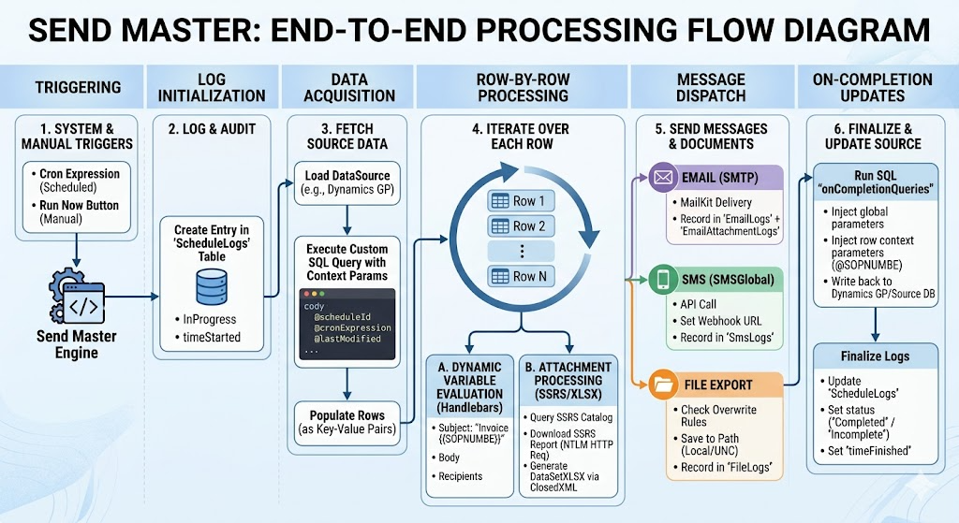
- Triggering: A schedule is initiated by the system's background scheduler (using its cron expression) or manually when a superuser clicks the Run Now button in the Blazor web application.
- Log Initialization: The Send Master engine opens a database session (SendMasterContext) and writes a new row to the ScheduleLogs table with status = ScheduleStatus.InProgress and timeStarted = DateTime.Now.
- Data Acquisition:
  - The engine loads the connection details of the configured DataSource (such as the SQL Server database for Dynamics GP).
  - It executes the custom SQL query specified in the schedule's DataSet property.
  - While executing this query, Send Master automatically binds query context parameters: @scheduleId, @cronExpression, and @lastModified.
  - The query returns a database reader, which is mapped into a list of row dictionaries (key-value pairs of column names and values).
- Row-by-Row Message Evaluation: The engine loops through each row returned by the SQL query. For each row, a corresponding message or file delivery task is generated:
  - Attachment Processing: If the schedule specifies attachments, the engine generates them:
    - SSRS Reports: The engine queries the SSRS ReportServer.dbo.Catalog database to fetch and validate parameter definitions for the .rdl file. It then makes an NTLM-authenticated HTTP request to the SSRS report server endpoint (http://{host}/ReportServer) to download the report in the requested format (e.g. PDF or Excel).
    - DataSetXLSX: The engine runs a secondary SQL query for the attachment, evaluates the data, and writes the output directly into a .xlsx workbook using the ClosedXML library.
  - Dynamic Variable Evaluation:
    - Message parameters like the Subject, Body, Target Directory, and Recipient addresses (To, CC, BCC) are resolved for the current row.
    - If configured as a Literal, the text is parsed using the HandlebarsDotNet templating engine, using the database columns of the current row as context (e.g., replacing {{CustomerName}} with the actual customer name from that row).
    - If configured as a DataSetReference, the engine directly pulls the string value of the specified column.
- Message Dispatching:
  - Email Schedules: The email is built with the evaluated recipients, subject, body, and attachments. It is sent via SMTP using MailKit. The transaction is recorded in EmailLogs and the generated files are stored directly in EmailAttachmentLogs as a byte array (AttachmentContent) for historical archiving.
  - SMS Schedules: The text is generated and sent via SMSGlobal's API. If ReplyWebhookUrl is configured, Send Master appends webhook query parameters (scheduleId, scheduleLogId, and replyToken) to the SMSGlobal API callback registry to track user replies. The transaction is logged in SmsLogs.
  - File Schedules: The evaluated attachments are saved to the target local or UNC network path. Overwrite rules are checked: if overwriteFiles is false and a file exists, it stops writing. The transaction is logged in FileLogs.
- On-Completion Database Updates:
  - For each successfully delivered item, the engine runs the SQL commands listed in onCompletionQueries against the source database.
  - Send Master automatically passes tracking variables (@sent_subject, @sent_body, etc.) and all column values of the processed row as parameters prefixed with @ (e.g., @SOPNUMBE).
  - This is typically used in Dynamics GP to mark records as sent, log sending timestamps, or update transaction statuses.
- Finalize Logs: The engine updates the initial ScheduleLog entry in the database, setting status = ScheduleStatus.Completed (or Incomplete if exceptions occurred) and timeFinished = DateTime.Now.

7. Dynamics GP & SQL Server Integration Details
Dynamics GP integration is achieved dynamically through configuration rather than hardcoded dependencies:

A. DataSet Queries (Reading from GP)
A schedule connects to a configured Dynamics GP company database. The query (the DataSet property) pulls transaction rows (e.g. unposted invoices, vendor payments, customer statements). Send Master automatically attaches the following parameters to help filter the queries:
- @scheduleId: The unique ID of the schedule running.
- @cronExpression: The schedule's cron rule.
- @lastModified: The timestamp when the schedule config was last updated.
- @replyFrom / @replyTo / @replyMessage / @replyDate: (If running in response to an incoming SMS).

B. Dynamic Variable Evaluation (Handlebars)
Message parameters like subject, body, and recipient addresses are evaluated per row using HandlebarsDotNet:
- Set to Literal kind: Text can contain templated parameters referencing columns of the returned GP dataset.
- Example:
  - Subject: Invoice {{SOPNUMBE}} from {{CUSTNAME}}
  - Recipient: {{OREMAILS}}
  - Body: Dear {{CUSTNAME}}, please find your invoice {{SOPNUMBE}} attached.

C. SSRS Catalog Integration
To obtain the parameter schema of SQL Server Reporting Services (SSRS) reports, Send Master queries the SSRS system database catalog
It reads the .rdl XML content, extracts parameter rules, and verifies them. It then makes an NTLM-authenticated HTTP GET request to http://{ssrs-host}/ReportServer passing the query string variables to download the rendered report (PDF, XLS, XLSX) and attach it to the message.

D. Writing Back to GP (On-Completion Queries)
This is the primary way GP data is updated after delivery. Successful message dispatch triggers execution of onCompletionQueries against the source database. The SQL command is populated with:
- Global tracking parameters: @sent_scheduleId, @completedAt.
- Message properties: @sent_sendAsAddress, @sent_toAddresses, @sent_ccAddresses, @sent_bccAddresses, @sent_subject, @sent_body, @sent_destinations, @sent_message, @sent_origin, @sent_incomingUrl.
- Row Context Parameters: Every column in the dataset row is automatically injected as a parameter prefixed with @ (e.g., if the query pulled SOPNUMBE, it passes @SOPNUMBE).

8. SMS Response Webhooks
When an SMS schedule is configured with useVirtualNumber and the global SMSGlobal configuration defines ReplyWebhookUrl, Send Master sets the incomingUrl callback for the SMSGlobal API: {ReplyWebhookUrl}?scheduleId={scheduleId}&scheduleLogId={scheduleLogId}&replyToken= {smsLog.replyToken}
When the recipient replies to the virtual number:
- SMSGlobal hits the webhook endpoint.
- Send Master reads the payload as an SmsIncoming object.
- The system matches the reply pattern using case-insensitive regular expressions configured in the schedule's ReplyResponses (GetResponseForReply() method).
- If a match is found, it evaluates the reply dataset rules and generates the configured automatic reply message.

